Proposed for January 3, 2008
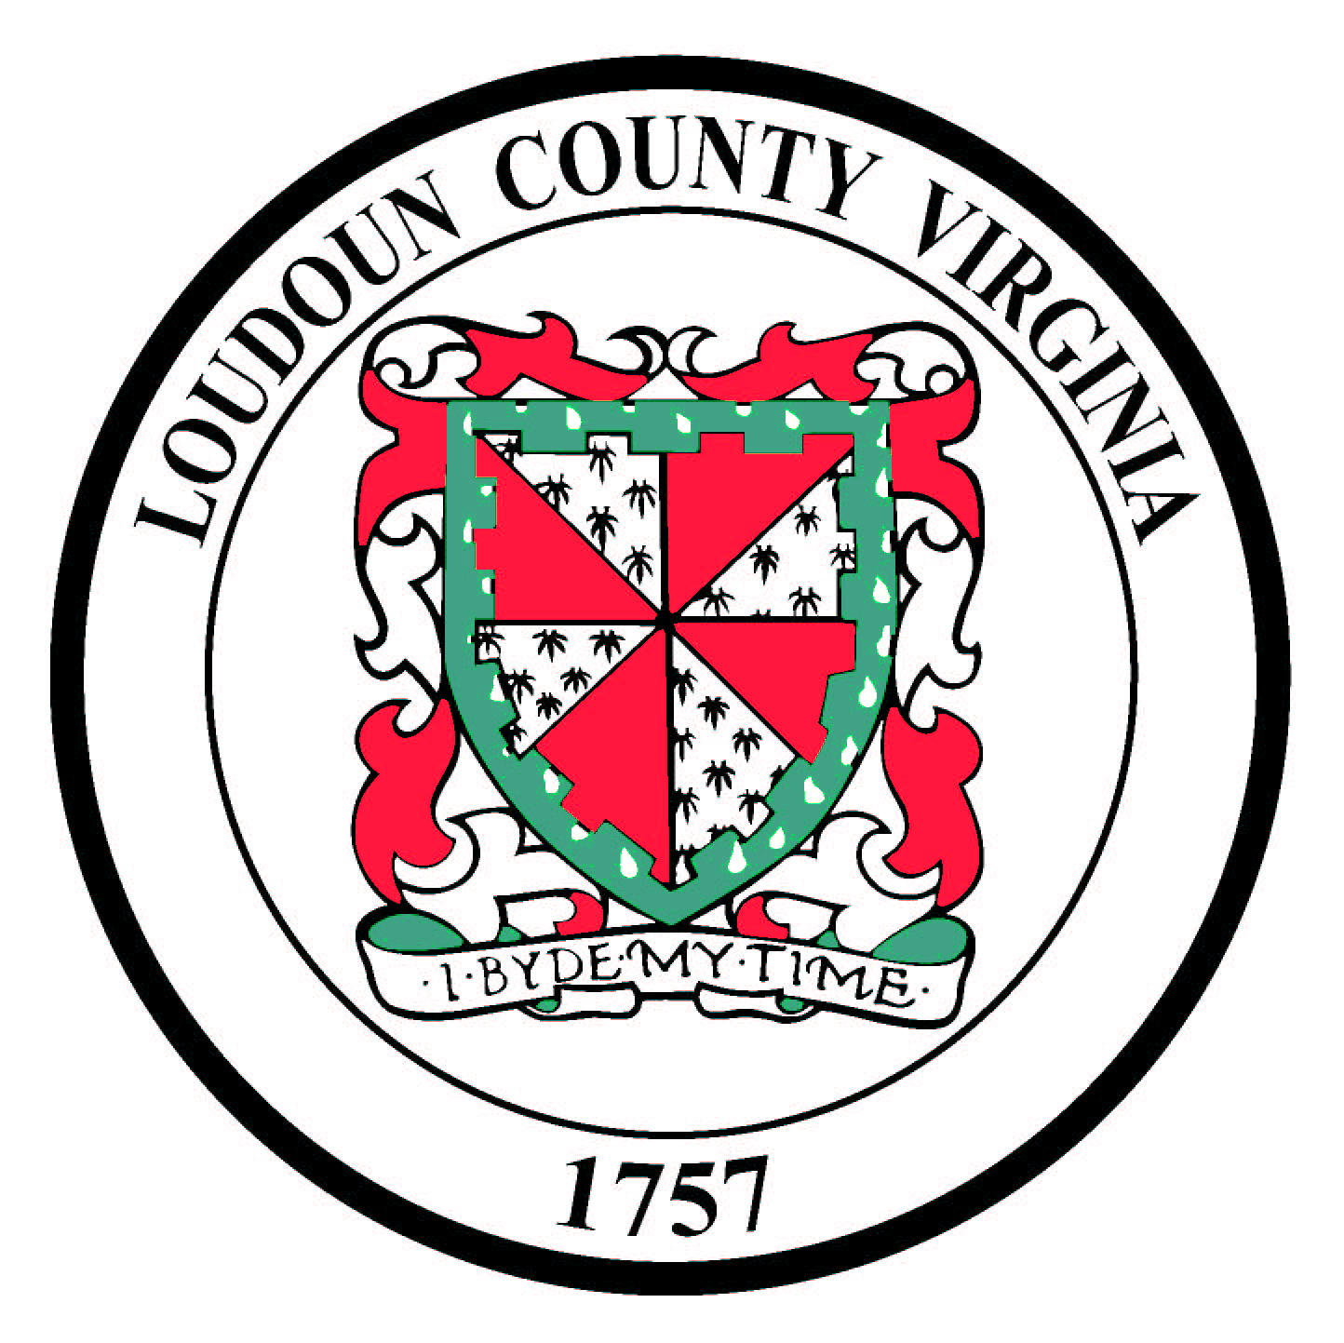

Code of Ethics
Board of Supervisors
Loudoun County, Virginia

Recognizing that persons who hold public office have been given a public trust and that the stewardship of such office demands the highest levels of ethical and moral conduct, any person serving on the Loudoun County Board of Supervisors should adhere to the following Code of Ethics.
1. Uphold the Constitution, laws and regulations of the United States and of all governments therein and never knowingly be a party to their evasion.
2. Put loyalty to the highest moral principles and to the people of Loudoun County, as a whole, above loyalty to individuals, districts, or particular groups.
3. Give a full measure of effort and service to the positions of trust for which stewardship has been granted; giving earnest effort and best thought to the performance of duties.
4. Seek to find and use the most equitable, efficient, effective and economical means for getting tasks accomplished.
5. Adopt policies and programs that are in accordance with the County's EEO policy, and that support the rights and recognize the needs of all citizens regardless of race, sex, age, religion, creed, country of origin or handicapping conditions.
6. Ensure the integrity of the actions of the Board of Supervisors by avoiding discrimination through the dispensing of special favors or unfair privileges to anyone, whether for remuneration or not. A member should never accept for himself or herself or for family members, favors or benefits under circumstances which might be construed by reasonable persons as influencing the performance of governmental duties.
7. Make no private promises of any kind binding upon the duties of any office, since a public servant has no private word which can be binding on public duty.
- Avoid even the appearance of a conflict of interest. A member should recuse himself or herself from participating in deliberations or voting on issues which might be interpreted as questionable or borderline conflicts of interest, and which might be perceived as rendering direct personal gain for himself or herself or for family members. If a Board member desires to vote on a questionable issue, he/she should seek the opinion of the County Attorney and made the opinion public before the vote in question.
- Engage in no business with Loudoun County government or school system, which is inconsistent with the State and Local Government Conflict of Interest Act or the Public Procurement Act.
10. Never use any information gained confidentially in the performance of governmental duties as a means of making private profit.
11. Expose through appropriate means and channels, corruption, misconduct, or neglect of duty when discovered.
12. Adhere to the principle that the public's business should be conducted in the public view by observing and following the letter and spirit of the Freedom of Information Act.
13. Recognize that interaction with the media is a vital link in maintaining good communication with the public. Board member comments to the media should be in a courteous, statesmanlike manner and should maintain the propriety of the Board when speaking to public issues, or to opinions of colleagues and citizens.
14. Make sure, when responding to the media, that a clear distinction is made between personal opinion or belief and a decision made by the Board of Supervisors.
15. Review orally and in public session at the annual organizational meeting each of these principles.
16. Pledge to honor and uphold these principles, ever conscious that public office is a public trust.

________________________________
Scott K. York – Chairman

____________________________
Jim Burton – Blue Ridge District

_________________________________
Lori Waters – Broad Run District

_________________________________
Sally Kurtz – Catoctin District

_________________________________
Stevens Miller – Dulles District

____________________________
Kelly Burk – Leesburg District

_________________________________
Andrea McGimsey – Potomac District

_________________________________
Eugene Delgaudio – Sterling District

_________________________________
Susan Buckley – Sugarland Run District

