OVERVIEW OF ZMAP 2005-0031, BRADDOCK VILLAGE-REVISED PROPOSAL AS OF 02/06/08-BASED UPON EXCERPTS FROM THE DEPARTMENT OF PLANNING STAFF REPORT DATED FEBRUARY 11, 2008

Summary of Proposal

The Nicholas/Farkas Joint Venture and John D. M. Crerar, Jr. have submitted an application to rezone approximately 148.5 acres from the TR-1UBF (Transitional Residential-1) and TR-3UBF (Transitional Residential-3) zoning districts to the PD-H6 (Planned Development-Housing) zoning district in order to develop up to 499 residential dwelling units, including affordable dwelling units as may be required by the Zoning Ordinance (ZO), at an overall residential density of 3.36 dwelling units per acre. Portions of these properties are located in the Airport Impact (AI) Overlay District, outside of but within one (1) mile of the Ldn 60. This application is subject to the Revised 1993 Zoning Ordinance.

The property is located on the south side of Braddock Road (Route 620), west of the planned Route 659 Relocated, and east of Lightridge Farm Road (Route 705) in the Dulles Election District.

The area is governed by the policies of the Revised General Plan, which designates the area as part of the Transition Policy Area (Upper Foley and Upper Broad Run Subareas). The Upper Foley and Upper Broad Run Subareas recommend residential uses in clustered patterns at densities of 1 dwelling unit per 3 acres or 1 dwelling unit per acre as established in the current zoning patterns.

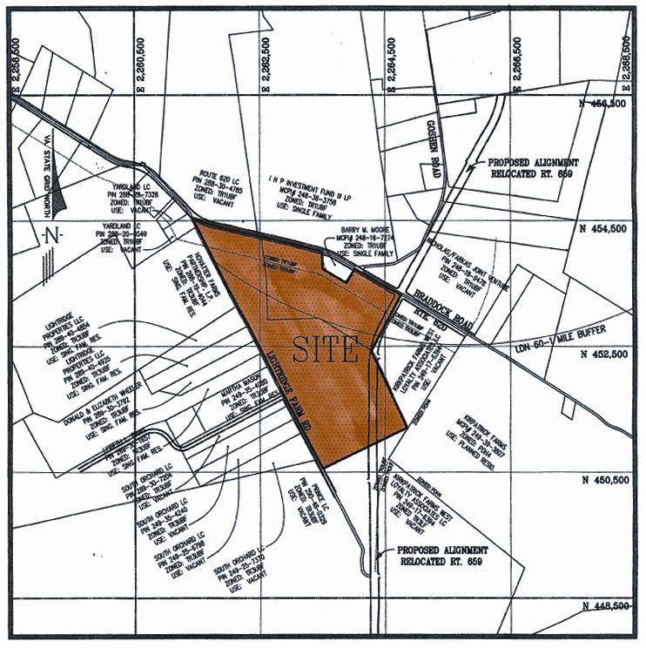

Summary of Issues Identified by the Loudoun County Staff: Source-Department of Planning Staff Report, dated February 11, 2008

Topic | Issues Examined and Status
Land Use | - Transition Area policies anticipate up to 66 dwelling units in a clustered pattern: the applicant has proposed 499 dwelling units in a suburban pattern not consistent with County policies.
Green Infrastructure | - Lots placed adjacent to wetlands and does not sufficiently protect the long-term viability of the wetland resources.  - Athletic field, parking lot, and SFD dwelling units proposed in high-quality forest area, while non-forested area kept open.  - Natural resources not adequately buffered.  - Based on downstream presence of Occoquan Reservoir, enhanced extended detention basins and wet ponds are recommended, along with a commitment to LID techniques, rather than the proposed dry ponds.  - Site contains cemetery, possibly associated with slaves, and remains of 18th Century domestic site; covenants, easements, archival research, signage, and public narrative recommended.
Transportation | - Traffic Study for original application no longer valid. Entrances altered, school and athletic field proposed, with no analysis of service levels.  - Clarification needed for roadway phasing and commitments.  - Cumulative impact of suburban densities in the Transition Area not considered.  - Substandard trail size proposed. Sidewalks proposed only on one side of several roads. Enhancements to trail and sidewalk system recommended.  - Noise study proposed as part of preliminary subdivision plan submittal: noise study requested as part of zoning application to ensure that appropriate design measures can be taken. Changes to noise proffer language requested.
Open Space | - Transition Area policies call for at least 50 percent open space, or 75 acres, predominantly surrounding the residences, at the site’s periphery.  - The applicant proposes 34 percent open space, or 48 acres, scattered throughout the development in a Suburban pattern.

Loudoun County Staff Findings and Recommendation

Findings

- The proposed rezoning is not fully consistent with the land use policies as set forth in the Revised General Plan, which was affirmed by the Board of Supervisors on November 8, 2006, when CPAM 2005-0003 was denied. The applicant proposes 499 dwelling units at a density of 3.36 dwelling units per acre when a maximum of 66 dwelling units and densities of 1 dwelling unit per 3 acres or 1 dwelling unit per acre, as established in current zoning patterns, are envisioned by the Revised General Plan. Open space is not provided at levels anticipated by the Comprehensive Plan and the proposed design does not adequately preserve or protect elements of the Green Infrastructure, including forest, wetland, and archaeological resources.
- The uses proposed in the application (PD-H6, administered under the R-8 and R-16 zoning districts), are incongruous with the surrounding uses and incompatible with the land use policies of the Upper Broad Run and Upper Foley Transition Policy Subareas.
- The proposed rezoning application is located in an area that is not planned for substantially greater public facilities and services to accommodate development densities above 1 dwelling unit per acre or 1 dwelling unit per 3 acres, as established in current zoning patterns. The proposal would exceed the capacity of existing public services, provides no public facilities, and assumes that approval of other developments will be sufficient to serve the needs of the community.
- The proposed rezoning application would not create a balance of employment uses in conjunction with the proposed increase in residential densities, would create undue fiscal stress for the County to provide needed facilities and services, and is not necessary to address housing demands in the foreseeable future.
- The proposed rezoning application is located in an area that is not planned for a substantially greater transportation network to accommodate development densities above 1 dwelling unit per acre or 1 dwelling unit per 3 acres, as established in current zoning patterns. Increasing the intensity of land uses in this portion of the Transition Policy Area would create unacceptable impacts on Route 50 at this time, due to lack of state funding for transportation improvements.
- The proposed rezoning does not provide the visual and spatial transition between the suburban development in the east and rural development in the west, as anticipated for the Transition Policy Area.

Loudoun County Staff Recommendation

Staff recommends denial of the application based on inconsistency with the Revised General Plan land use policies regarding density.

