ASHBURN’S WATER IS AT RISK ……
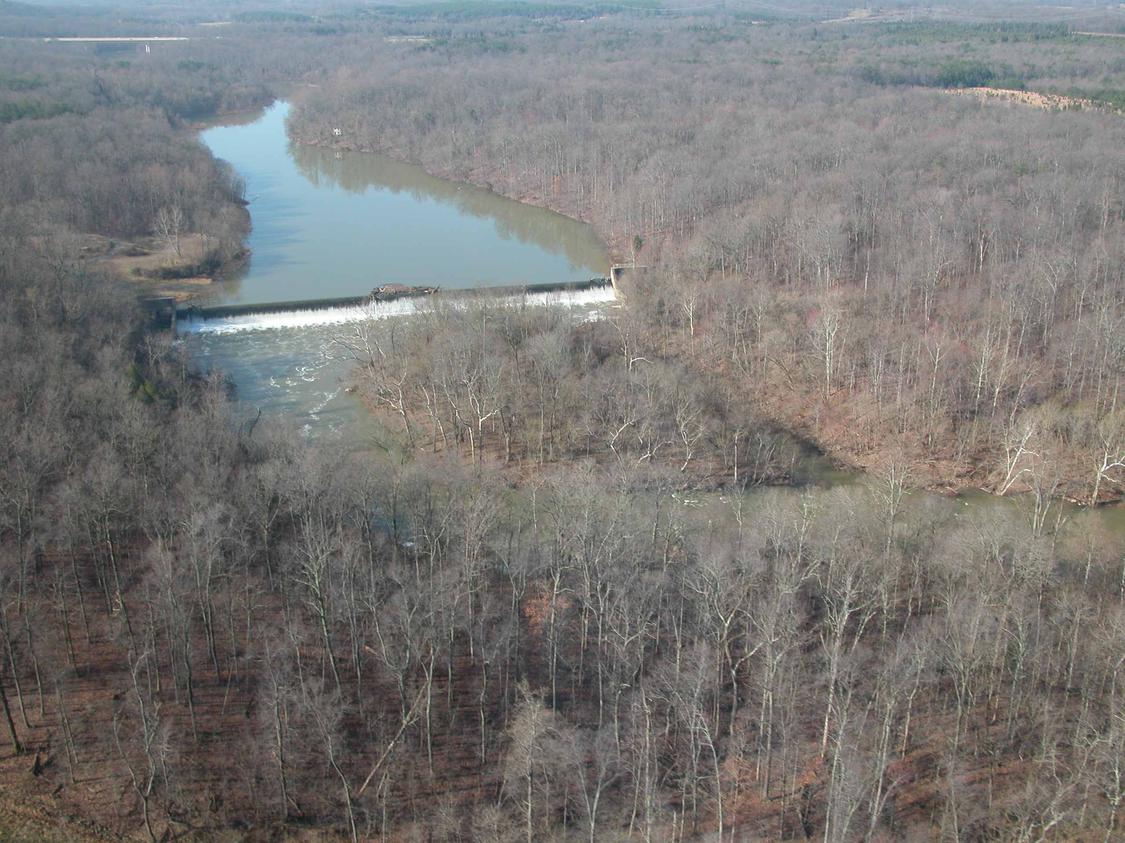
.
Most people in Ashburn don’t realize that Goose Creek Reservoir is our water source-- and for much of Eastern Loudoun as well. However, the clean and safe water we all take for granted will be endangered if Ridgewater Park - a proposed large scale development - is built adjacent to it. This environmentally sensitive area can only be protected if our community lets the Board of Supervisors know that they must vote NO on this proposal – our very health and safety is at stake.

Drinking water intake pipe in this area

Ridgewater Park proposal for 1946 houses, office & retail covers most of this area and beyond

Common toxins such as these (fertilizers, pesticides, gasoline, anti-freeze, etc), used by residents everywhere could readily contaminate the reservoir, due to the proximity and density of this development, and the loss of necessary buffer zones. Trace amounts of these chemicals are considered a biohazard, and must be safeguarded against.

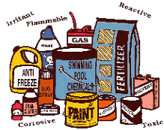

HELP protect our drinking water ---- Tell the Board of Supervisors to safeguard the health, safety and welfare of Loudoun residents by voting ‘NO’ on the Ridgewater CPAM and rezoning. Email the Board at BOS@loudoun.gov.

Attend the Public Hearing, Thur., Feb. 15th, 6:30 pm, County Gov. Center, Leesburg.

ASHBURN CITIZENS UNITED* Ashburn, VA For more information please contact us at 703.298.3260
*We are a community citizen network supporting sustainable, manageable growth only at a pace Loudoun citizens can afford.
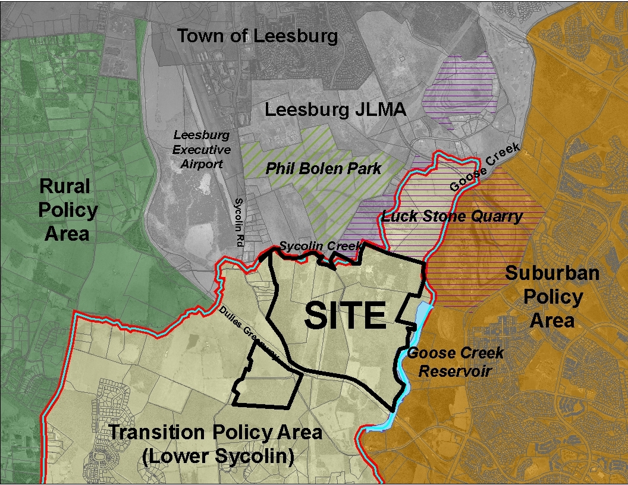

The proposed Ridgewater Park development is indicated by the SITE area above. As the name implies it sits directly above Ashburn’s water supply, namely Goose Creek Reservoir. It is contained within an area called the TRANSITION POLICY Area – which is meant to be a buffer between the suburban and rural policy areas. Further, the west side of Goose Creek is the only land use decision that the County has made that acknowledges the importance of protecting the water supply. That should not change to accommodate a developers’ plans.

Loudoun County staff recommends denial of this application. In addition, such a development would generate the following negative impacts:
- Traffic would increase by 40,000+/- daily car trips, many headed our way
- $70 million in capital costs and operating costs – paid by taxpayers
- Too close to the Luck Stone Quarry and Leesburg Airport
- If the Transition Area becomes suburban it will set a dangerous precedent for the entire area
- Inadequate transportation proffers associated with this development
- Powerline considerations

It does not make sense to threaten our water supply further by changing the Transition Area to Suburban, or to approve large-scale development there. Please join other concerned Loudoun residents and tell the Board of Supervisors to protect the health, safety and welfare of our community.

Email the Board of Supervisors at BOS@loudoun.gov. Attend the CPAM Public Hearing - Thurs., February 15th, at 6:30 pm, County Gov. Center, Leesburg.

