Loudoun Reservoirs, Drinking Water & You

If you care about clean ,safe drinking water and want to protect the water that you drink, you must take action now!

It does not make sense to threaten our water supply further by changing the Transition Area to Suburban, or to approve large-scale development there.

Tell the Board of Supervisors to protect
the health, safety, and welfare of Loudoun residents
by voting “NO” on the Ridgewater CPAM and rezoning.

Email the Board of Supervisors at: BOS@loudoun.gov
Attend the public hearing on Ridgewater Park
Tuesday, December 11, 2007, County Government Center
The hearing starts at 4:00 PM
We estimate public comment on Ridgewater Park will begin around 6:30 PM

Get involved to protect your drinking water!
Call Gem Bingol for more information at 703-669-2205

SCROLL DOWN FOR DRINKING WATER INFORMATION
AND PHOTOS

Eastern Loudoun residents get their drinking water from two sources: Goose Creek and the Potomac River.
- Ashburn residents mostly drink water pulled from Goose Creek, and the rest of eastern Loudoun mostly drinks water from the Potomac (although the supplies are interconnected).
- The Goose Creek drinking water plant (below) is owned and operated by the City of Fairfax, which sells 2/3s of their water to LCSA for Loudoun residents.
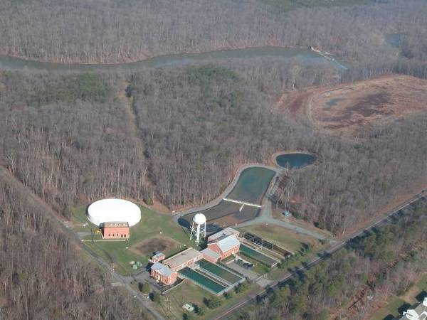
Photo: Missy Janes

The Goose Creek water supply comes from the Goose Creek watershed which encompasses almost half of Loudoun County and a quarter of Fauquier County.
- Over 27% of the land in the Goose Creek watershed, particularly in the important headwater streams, has been protected by private conservation easements, which benefit the many people who live elsewhere but drink water from the creek.

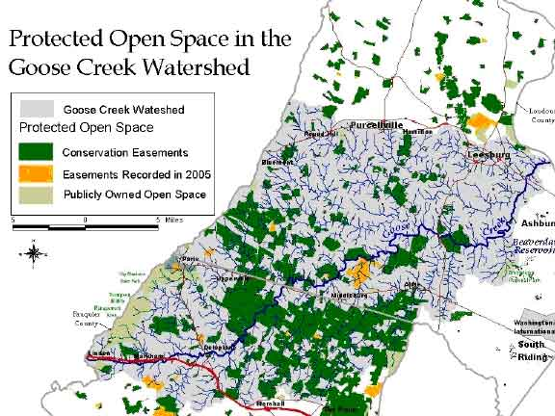
Source: Piedmont Environmental Council

Two reservoirs, Goose Creek and Beaverdam are part of the supply system. .In the area closest to the reservoirs, the land is not well protected, though. The drinking water supply faces threats, mainly due to development.
- These threats are outlined in the LCSA document “Goose Creek Source Water Protection Program.”
- The 2005 Water Quality Report for the City of Fairfax states, “Recently, the Virginia Department of Health conducted a source water assessment of our system and determined that the reservoirs were of high susceptibility to contamination according to the criteria developed by the State and its approved Source Water Assessment. You may obtain a copy of this report with detailed information concerning land use and any known contaminants by calling the City of Fairfax Utilities Department at 703-385-7920.”

Beaverdam Reservoir (below) is a water storage facility. When the creek is running high, water is siphoned off to be stored until the creek is low. Then it is released back to the stream.

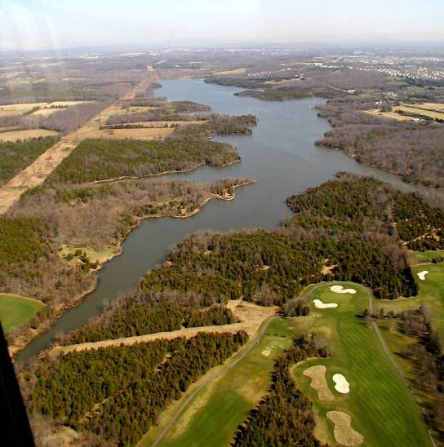
Photo: Gem Bingol

Goose Creek Reservoir (below) is right in the main body of the creek, and water is piped to the water treatment plant directly from the stream.

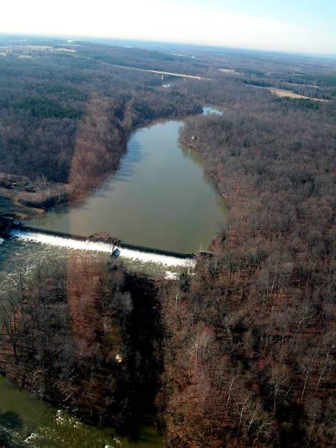
Photo: Missy Janes

The land around the reservoirs falls into 2 distinct policy areas according to the Loudoun County Comprehensive Plan.

- On the east side of Goose Creek and the reservoirs, land can be developed according to Suburban Area policies at higher densities (the brown side below).
- On the west side of Goose Creek and the reservoirs, the land can be developed according to Transition Area policies and lower densities (the grey side below).

Source: County staff report

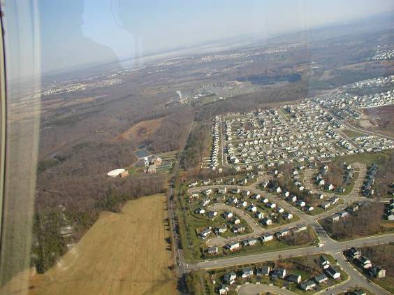
Photo: Gem Bingol

In the Suburban area to the east of Goose Creek and the reservoirs, most Ashburn and area neighborhoods lie east of Belmont Ridge Road (above in the center of the photo).
- Belmont Ridge Road lines up with the ridge that separates most of those neighborhoods from the reservoir watersheds.
- Run-off from most of the area neighborhoods does not flow toward the reservoir.

On the west side of Belmont Ridge Road (and still in the Suburban area), several developments have been already approved, but are not yet been built.
- As that occurs, run-off impacts on the reservoir will increase noticeably.

In the Transition area on the west side of the Goose Creek and reservoirs, the land is currently mostly undeveloped with a mix of forest and field.
- The proposed Ridgewater site is mostly forested.
- There is also a fairly high percentage of forest cover south along the creek and also in the Beaverdam Reservoir watershed.

MapSource: County staff report

If Ridgewater Park is rezoned to Suburban densities it will not match the Comprehensive Plan for the Transition Area. The threat to the integrity of the Plan AND to the water supply increase exponentially. With the forests stripped and replaced with lawns and hard surfaces, run-off will increase substantially.
  - Most of the rain that falls on forested areas doesn’t run off; it gets taken up & released back to the air by the trees.
    - A typical forest of 10,000 trees will retain approximately 10 million gallons of rainwater a year.
    - A mature tree absorbs thousands of gallons of rain water through its roots yearly.
    - Trees also intercept thousands of gallons of rain a year, captured by the tree canopy surfaces—leaves, branches, trunk bark--which evaporates instead of running off.
.

This view is from the Goose Creek Reservoir southward towards the Greenway in the area of the Ridgwater Park proposal. How much water do you think those trees absorb? How much runoff do you think they prevent?

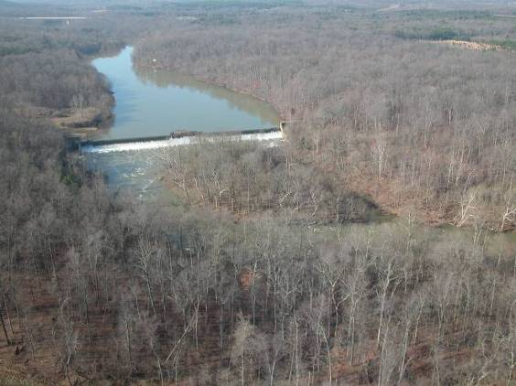
Photo: Missy Janes

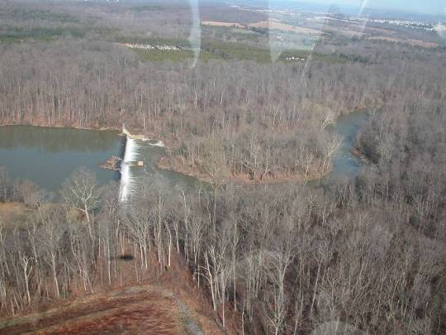
Photo: Missy Janes

The geology & soils in the Transition Area are more prone to runoff due to their natural characteristics.
  - There is a hard rock base and the soils tend to be wet because rainwater cannot be readily absorbed.
  - With the trees gone, streams fill up quickly with runoff rainwater that carries lots of dirt with it. The speeding water scours the streambed more, increasing the erosion from the banks and bottom.

This is what a stream looks like as a result of erosion.
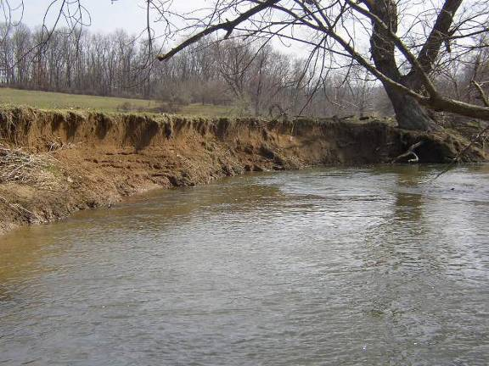
Photo: Darrell Schwalm

With a high amounts of sediment & erosion, stream water often looks like this after a rain.
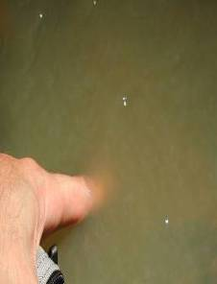
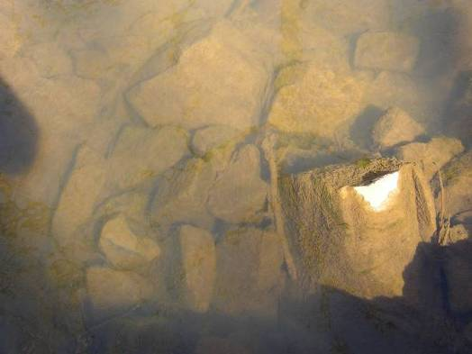:
Photo:Darrell Schwalm

Sediment in the water will get carried to the reservoir, where a lot will fall to the bottom in the slower moving, deeper water, and eventually fill it up.
  - Since the Goose Creek Reservoir was constructed over 40 years ago, it has been dredged once (around 10 years ago), due to accumulated sediment.
  - The dredging cost $1,688,500 to remove 58,500 cubic yards of silt, which was placed on land close to the water treatment plant.

Here’s the sediment from the first dredging. With lots of new development close by, how often do you think the reservoir might need to be dredged in the future? And where would the silt go? (It has to be treated as toxic material, and hauling it long distances will increase the cost).

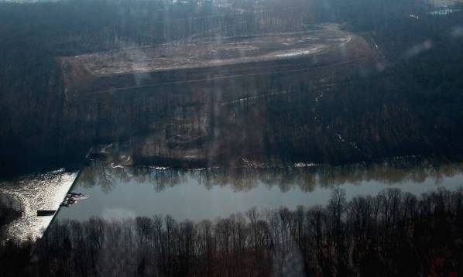
Photo: Darrell Schwalm

Loudoun County has gotten protective stream-side setbacks with each of the developments coming to the east side of the reservoir, but still each will contribute a new load of runoff laden with sediment and toxins. The cumulative impacts of all the individual developments will be greater than the sum of each one.

The County is charged with monitoring soil & erosion preventive measures carefully to make sure that they are properly maintained, and perform properly, so that they don’t look like this:

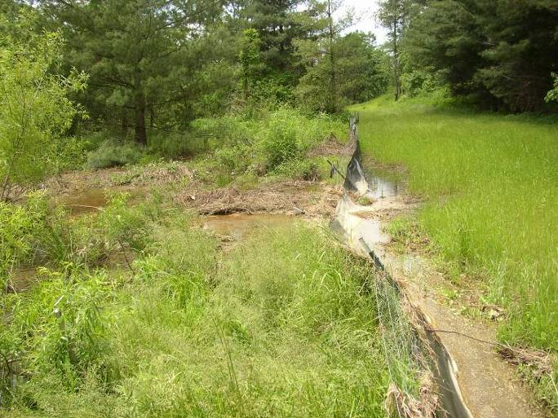
Photo: Darrell Schwalm

or this:
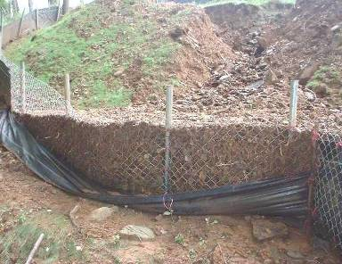
Photo: Darrell Schwalm

But even the best maintained artificial system cannot match the protection of a forest against run-off and water quality degradation.

LCSA’s Goose Creek Source Water Protection Program models the impacts to the drinking water supply based on the Comprehensive Plan. It shows that water quality will be diminished. This document is available by calling the LCSA offices at 703-771-1095.

If the County approves development that does not match the Comprehensive Plan, the water quality impacts will only get worse.

If you care about clean ,safe drinking water and want to protect the water that you drink, you must take action now!

It does not make sense to threaten our water supply further by approving suburban density development in the Transition Area.

