Please Help Our Community!
Speak out on another costly development proposal for Leesburg and Loudoun
Who wants more traffic, houses instead of businesses, and a bigger tax burden?

Insist on Fairness!
CROSSTRAIL Development (see map)

Crosstrail doesn’t match Town or County growth plans -- staff reveals many problems!
Ask County leaders to protect our public interest:
Agree to equal partnership with Leesburg
Keep existing growth plan
Reject negative impacts

Send an email to: Loudounpc@loudoun.gov & bos@loudoun.gov and
copy the Town of Leesburg: council@leesburgva.gov and planningcommission@leesburgva.gov

The Crosstrail development with 1,366 houses will hurt!
Traffic
- Almost doubles in southern Leesburg in 4 years, closer to triple when completed
- County & Town staff find developer’s traffic analysis and road plans inadequate
- Sycolin Road improvements & others could be swamped on completion

Less $$ in our pockets
- Taxpayers will pay for most of the $23.5 million to build schools *
- Taxpayers will make up a $390k yearly deficit to run the schools *--more if proposed commercial isn’t complete in 5 years. In Ashburn, commercial development still lags behind housing 18 years later.
- If Leesburg airport & retail businesses suffer, it’s bad for us, too

*Analysis by Piedmont Environmental Council, based on developer’s proposal & County formulas.
(Contact Ed Gorski for more info at 703-669-2207)

Background
Last year developers of Crosstrail and Creekside pushed for big changes to the County growth plan: Over 6,000 houses by Leesburg Airport & swapping the easily-developed Bolen Park property for less usable land. Eventually bowing to public outrage, the County rejected the swap and put the proposed changes on hold.
Then Leesburg asked for the County’s cooperation to bring the Crosstrail property into town, and proposed an equal partnership to review the growth plan. County leaders didn’t respond.
Now County leaders are again favoring these developers over us: They’ve rejected Leesburg’s proposals. They are set to consider changing the growth plan to suit developer proposals.

Crosstrail site and vicinity
Map source: County Staff Report
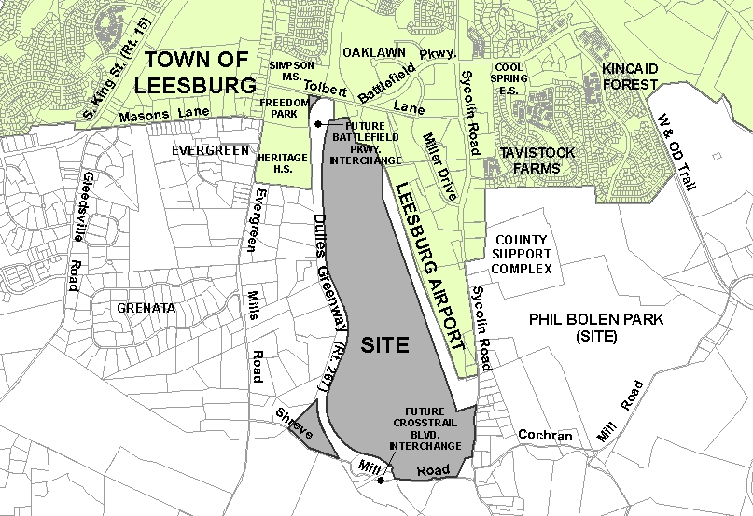
The Creekside development (revised & renamed Ridgewater Park) is now south of Cochran Mill Rd & Sycolin Creek, east of the Greenway. Due
for public hearing later in the year.

Learn more; get involved to protect our community:

1) Make your voice heard! Send comments to: bos@loudoun.gov, loudounpc@loudoun.gov, and be sure to copy the Town of Leesburg elected officials: council@leesburgva.gov and planningcommission@leesburgva.gov.

2) Spread the word: Word of mouth is so important; please print this flyer and give it to your neighbors and friends. Urge them to send an email with their comments.

3) Contact us at LeesburgCitizens@hotmail.com to volunteer-- We support fair and balanced planning in an open, inclusive public process. With good planning and careful decisions, we think Leesburg can become an even better place to live.

We are a member of the Campaign for Loudoun’s Future. See www.loudounsfuture.org

Sure, we all expect Leesburg to grow,
but development should improve life in our community.
Proposals should be fair or we should say no!

