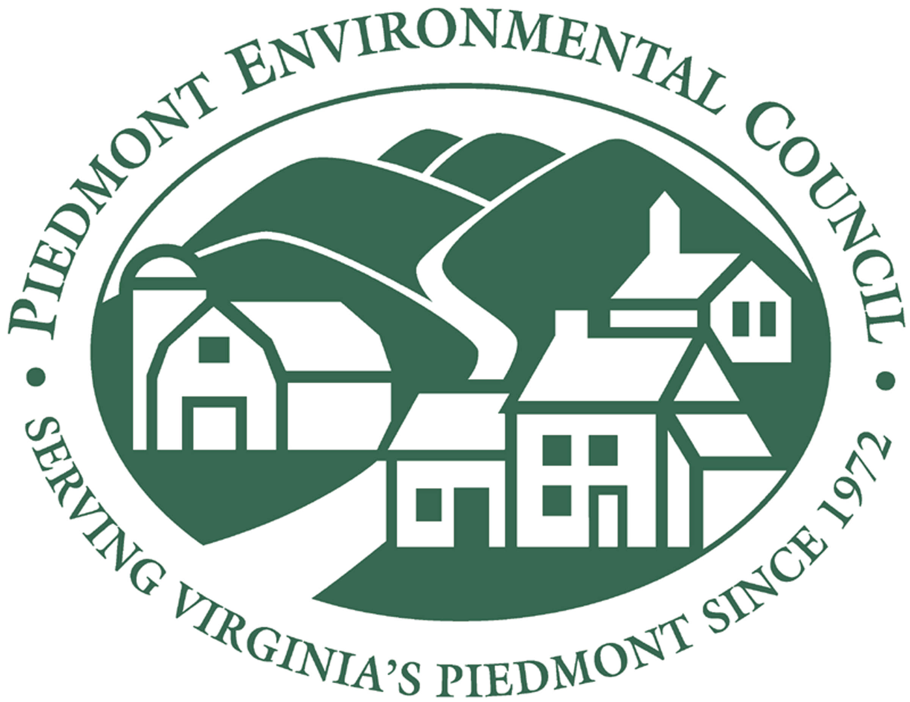

It’s Your Community…Make Your Voice Heard

Dear Neighbor:

The Piedmont Environmental Council (PEC) wants to know your thoughts and priorities for your community. We cordially invite you to attend a free community visioning session [details below]. The session is being held to listen to the viewpoints and concerns of residents about the future and how best to plan for those needs.

The results from the visioning session will be presented to planning and government officials as an alternative to six developer schemes that have been submitted to the Loudoun County Board of Supervisors which could add more than 22,000+ residential units to the Dulles South and Ashburn area. Many of the proposed residential units would be packed into the Route 50 corridor further exacerbating our already congested roads and negatively impacting our quality of life.

Your views are important to us, and as such we hope that you will be able to join us for this special program.

Piedmont Environmental Council
Leesburg, Virginia
703-669-4990

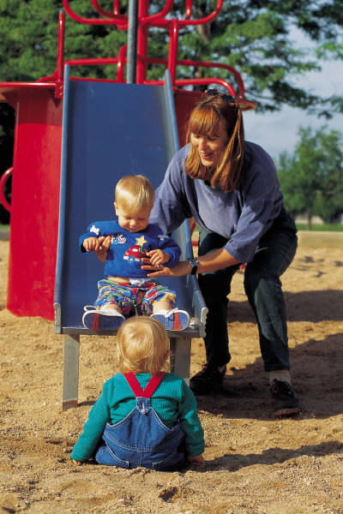
Community Visioning Session
Wednesday, June 8, 2005

Arcola Elementary School
24328 Goshen Road ● Aldie
7 to 9PM

The only thing you need to bring is your opinion!
www.pecva.org

